- SINGLE INHERITANCE :
Of course. This program is an example of single-level inheritance in Java. Let’s understand how it was written step by step.
1. Package declaration
package inheritance;
This tells Java that the classes belong to a package named inheritance.
If you are using an IDE such as Eclipse or IntelliJ, the file should be inside the corresponding inheritance package.

2. Creating the parent class A
class A {
A is the parent/superclass.
It contains two methods:
void first() {
System.out.println("this is a parent class");
}
The first() method simply prints a message.
The second method is:
void add() {
int x = 20, y = 30;
System.out.println("addition is" + (x + y));
}
Here:
- x = 20
- y = 30
- x + y = 50
- The result 50 is printed.
So class A provides the methods first() and add().

3. Creating the child class B
class B extends A {
This is the most important part.
The keyword extends establishes inheritance:
A → B
So B inherits the methods of A.
That means an object of B can access:
- first() — inherited from A
- add() — inherited from A
- subtract() — defined inside B
- main() — defined inside B

4. The main() method inside B
void main() {
System.out.println("this is is a child class");
}
This is not the actual Java program entry point because it does not have:
public static void main(String[] args)
It is simply a normal method named main().
In your program, it is called manually using:
obj.main();

5. Creating the subtract() method
void subtract() {
int a = 90, b = 49;
System.out.println("subtraction is" + (a - b));
}
Here:
90 - 49 = 41
So it prints:
subtraction is41
Notice that there is no space after "is". If you want cleaner output, write:
System.out.println("subtraction is " + (a - b));

6. Creating the actual main class
public class Singlelevel {
This is the class containing the actual Java entry point:
public static void main(String[] args)
The filename should therefore be:
Singlelevel.java

7. Creating an object of class B
Inside the main method:
B obj = new B();
This creates an object called obj of class B.
Because B extends A, the object can also access the methods inherited from A.
Think of it like this:
A
/ \
first() add()
↑
|
B
main()
subtract()
Therefore, obj can call all four methods.

8. Calling the methods
First:
obj.add();
add() belongs to A, but B inherited it.
Output:
addition is 50
Then:
obj.subtract();
subtract() belongs directly to B.
Output:
subtraction is 41
Then:
obj.main();
This calls the normal main() method defined inside B.
Output:
this is is a child class
Finally:
obj.first();
first() is inherited from A.
Output:
this is a parent class
Complete flow
Singlelevel.main()
|
↓
B obj = new B();
|
├── obj.add() → inherited from A
|
├── obj.subtract() → belongs to B
|
├── obj.main() → belongs to B
|
└── obj.first() → inherited from A
Output
addition is 50
subtraction is 41
this is is a child class
this is a parent class
Why is it called single-level inheritance?
Because there is only one inheritance level:
Parent class
A
↓
Child class
B
B directly inherits from A, so this is called single-level inheritance.
One small correction I recommend is changing "this is is a child class" to "this is a child class" and adding spaces after "is" in the addition/subtraction messages.

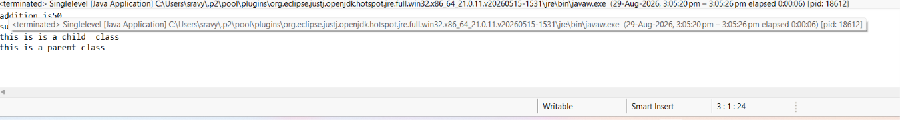
2.MULTILEVEL INHERITANCE :
1. Package declaration
package inheritance;
This places all the classes in a package called inheritance.

2. Parent class A
class A {
A is the first/parent class.
It has two variables:
int x = 28;
int y = 34;
So:
- x = 28
- y = 34
It also has an add() method:
void add() {
int w = 22;
System.out.println("addition is " + (x + y + w + 1));
}
Here:
x + y + w + 1
= 28 + 34 + 22 + 1
= 85
So if A's version of add() is executed, the output is:
addition is 85

3. Class B extends class A
class B extends A {
The keyword extends means that B inherits from A.
So the relationship is:
A
↓
B
Because B extends A, B can access the variables and methods of A, such as:
x
y
add()
Class B also has its own variable:
float s = 23.3f;
And its own method:
void mul() {
System.out.println("multiplication is " + (s * 2));
}
The calculation is:
23.3 × 2 = 46.6
So B's mul() would produce:
multiplication is 46.6

4. Class C extends class B
class C extends B {
This creates the second level of inheritance:
A
↓
B
↓
C
Therefore, C gets access to members inherited by B from A.
So a C object can access:
x
y
s
add()
mul()
And C also has its own variable:
int a = 23;

5. Method overriding in C
The add() method from A is rewritten in C:
@Override
void add() {
int w = 22;
System.out.println("addition is " + (x + y + w + 89));
}
The @Override annotation tells Java that this method is overriding a method inherited from the parent class.
The original calculation in A was:
x + y + w + 1
But C changes it to:
x + y + w + 89
Therefore:
28 + 34 + 22 + 89
= 173
So when you call:
obj.add();
the add() method of C executes, not the one in A.
Output:
addition is 173

6. mul() is also overridden
Class B has:
void mul() {
System.out.println("multiplication is " + (s * 2));
}
But class C defines its own mul():
void mul() {
System.out.println("multiplication is " + (s * 80));
}
The C version changes the calculation from:
s × 2
to:
s × 80
Since:
s = 23.3
the calculation is:
23.3 × 80 = 1864.0
Therefore:
obj.mul();
produces:
multiplication is 1864.0
It would be clearer to add @Override here too:
@Override
void mul() {
System.out.println("multiplication is " + (s * 80));
}

7. div() method in C
The div() method is newly created in class C:
void div() {
System.err.println("division is " + (a / 3));
}
Here:
a = 23
Since both a and 3 are integers:
23 / 3 = 7
Java performs integer division, so the decimal part is discarded.
Therefore:
division is 7
System.err.println() prints to the standard error stream rather than the standard output stream. In most IDEs, you will still see it in the console.

8. Creating the object
The actual program starts here:
public class Multilevel {

public static void main(String[] args) {
Then an object of class C is created:
C obj = new C();
Because C inherits from B, and B inherits from A, this object has access to the inherited members.
You can visualize it as:
A
x, y
add()
↓
B
s
mul()
↓
C
a
add() → overridden
mul() → overridden
div()

9. Calling the methods
obj.add();
Calls C's overridden add():
addition is 173
Then:
obj.mul();
Calls C's overridden mul():
multiplication is 1864.0
Then:
obj.div();
Calls C's own div() method:
division is 7
Final output
addition is 173
multiplication is 1864.0
division is 7
Why is this called multilevel inheritance?
Because inheritance occurs through more than one level:
A
↓
B
↓
C
- A is the parent of B.
- B is the parent of C.
- Therefore, C indirectly inherits members from A.
This is the main concept your program is demonstrating: multilevel inheritance + method overriding.
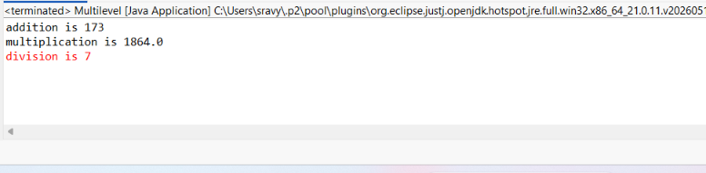
3.HIREICHAL INHERITANCE :
1. Package declaration
package inheritance;
This places the classes in a package named inheritance.

2. Parent class A
class A {
A is the parent/superclass.
It contains two variables:
int x = 67;
int y = 87;
These variables can be accessed by its child classes B and C.
Class A also contains the add() method:
void add() {
int z = 23;

System.out.println("addition is " + (x + y + z));
}
The calculation is:
67 + 87 + 23 = 177
So if A's add() were called, the output would be:
addition is 177

3. Class B extends A
class B extends A {
The keyword extends means that B inherits from A.
So:
A
↓
B
Because B extends A, it gets access to:
x
y
add()
Method overriding
B has its own add() method:
@Override
void add() {
int z = 23;

System.out.println("addition is " + (x + y + z + 23));
}
This is called method overriding because B provides a new implementation of the add() method that already exists in its parent class A.
The @Override annotation tells Java that this method is intended to override the parent's method.
The calculation is:
67 + 87 + 23 + 23
= 200
Therefore:
ch.add();
will call B's version and produce:
addition is 200
It does not call A's version because B has overridden it.

4. sub() method in class B
void sub() {
System.out.println("subtraction is " + (x - y));
}
Since:
x = 67
y = 87
the calculation is:
67 - 87 = -20
Therefore:
ch.sub();
produces:
subtraction is -20
This method belongs specifically to class B.

5. Class C extends A
class C extends A {
This means C also inherits from A.
So the inheritance structure becomes:
A
/ \
B C
Both B and C independently inherit x, y, and add() from A.

6. Method overloading in class C
Inside C, you have:
void add(int a, float b, String n) {
int z = 23;

System.out.println("addition is " + (x + y + z + b + a));
System.out.println("name is " + n);
}
This is called method overloading.
Why?
Because the parent class has:
void add()
while C has:
void add(int a, float b, String n)
The method name is the same, but the parameters are different.
add()
↓
no parameters

add(int, float, String)
↓
3 parameters
Therefore, Java treats them as different methods.
Calculation
You call:
cs.add(23, 23.f, "saranya");
So:
a = 23
b = 23.0
n = "saranya"
And:
x + y + z + b + a
= 67 + 87 + 23 + 23.0 + 23
= 223.0
So the output is:
addition is 223.0
name is saranya

7. sub(float s) in class C
Class C has another method:
void sub(float s) {
System.out.println("subtraction is " + (x - s));
}
This method takes a float parameter.
You call it with:
cs.sub(47.56f);
Therefore:
x = 67
s = 47.56
Calculation:
67 - 47.56 = 19.44
So the output will be approximately:
subtraction is 19.44

8. Creating objects
Inside the main method:
B ch = new B();
C cs = new C();
Two different objects are created:
ch → object of B
cs → object of C
ch can access the members of B and inherited members of A.
cs can access the members of C and inherited members of A.

9. Calling methods using ch
ch.add();
Since B overrides A's add(), Java executes B's version:
addition is 200
Then:
ch.sub();
calls B's sub():
subtraction is -20

10. Calling methods using cs
cs.add(23, 23.f, "saranya");
This calls the overloaded add() method in C.
Output:
addition is 223.0
name is saranya
Then:
cs.sub(47.56f);
calls C's sub(float) method.
Output:
subtraction is 19.44

Final output
Your program will produce approximately:
addition is 200
subtraction is -20
addition is 223.0
name is saranya
subtraction is 19.44
The three important concepts in this program
1. Hierarchical inheritance
A
/ \
B C
Both B and C inherit from A.
2. Method overriding
B overrides:
void add()
from A.
3. Method overloading
C has:
void add(int a, float b, String n)
which has the same method name add but different parameters.
So, in one sentence:
This program demonstrates hierarchical inheritance where classes B and C inherit from A, B overrides the add() method, and C demonstrates method overloading with a different add() method.
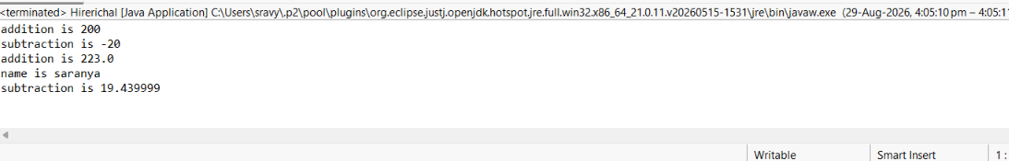
4.MULTPILE INHERITANCE :
1. Package declaration
You have written:
ackage inheritance;
There is a small mistake here. It should be:
package inheritance;
The keyword is package.
This means the classes belong to the inheritance package.

2. Creating the first interface Wes
interface Wes {
void add();
}
Wes is an interface.
It declares a method:
void add();
This is only a method declaration. There is no method body.
You can think of it as saying:
"Any class that implements Wes must provide an add() method."

3. Creating the second interface Wil
interface Wil {
void mul();
}
Wil is another interface.
It declares:
void mul();
So any class implementing Wil must provide a mul() method.
Now we have:
Wes → requires add()

Wil → requires mul()

4. Class Car implements both interfaces
This is the most important part:
class Car implements Wes, Wil {
The keyword implements is used when a class uses an interface.
Here, Car implements two interfaces:
Wes
↓
Car
↑
Wil
Or more clearly:
Wes Wil
| |
| |
└──→ Car ←───┘
This is how Java achieves multiple inheritance of type/contract through interfaces.

5. Implementing the add() method
Since Wes contains:
void add();
Car must provide the implementation:
@Override
public void add() {
int x = 55;
int y = 77;

System.out.println("Addition is " + (x + y));
}
Why public?
Interface methods are implicitly public, so when implementing them, the method in Car must be public.
Why @Override?
@Override
tells Java that this method is implementing/overriding a method declared in the interface.
The calculation is:
55 + 77 = 132
So:
Addition is 132

6. Implementing the mul() method
The second interface Wil contains:
void mul();
Therefore, Car must implement it:
@Override
public void mul() {
int a = 90;
int b = 889;

System.out.println("Multiplication is " + (a * b));
}
The calculation is:
90 × 889 = 80010
So the output is:
Multiplication is 80010

7. Creating the object
Inside the main method:
Car obj = new Car();
This creates an object of the Car class.
The variable obj can now call the methods implemented by Car.

8. Calling add()
obj.add();
This executes Car's implementation of the add() method from Wes.
Output:
Addition is 132

9. Calling mul()
obj.mul();
This executes Car's implementation of the mul() method from Wil.
Output:
Multiplication is 80010

10. Complete flow
You can understand the whole program like this:
Interface Wes
|
add()
|
↓
Car
↑
mul()
|
Interface Wil
Car is responsible for implementing both methods:
Wes → add() → Car implements it

Wil → mul() → Car implements it

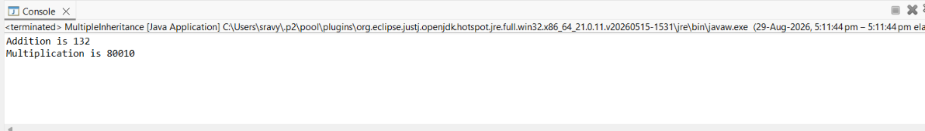

5.HYBRID Inheritance :

1. Package declaration
package inheritance;
This places the Java classes/interfaces inside a package named inheritance.

2. Create the first interface Ae
interface Ae {
void show();
}
- Ae is an interface.
- It contains one abstract method: show().
- Any class implementing Ae must provide the body of show().

3. Create the second interface Be
interface Be {
void animal();
}
- Be is another interface.
- It contains the method animal().
- A class implementing Be must define animal().

4. Create class Ce
class Ce implements Ae {

@Override
public void show() {
System.out.println("This a simple interface implementation");
}

public void dog() {
System.out.println("Dog is a pet animal");
}
}
Here:
class Ce implements Ae
means class Ce implements interface Ae.
Therefore, Ce must implement the show() method.
It also has its own method:
public void dog()
So Ce contains:
- show() → obtained from interface Ae
- dog() → its own method

5. Create class De
class De extends Ce {

public void dclass() {
System.out.println("This shows D class");
}
}
Here:
class De extends Ce
means De inherits from Ce.
Therefore, De automatically gets:
- show()
- dog()
It also has its own method:
dclass()
So the inheritance is:
Ae (Interface)
↑
|
Ce
↑
|
De

6. Create class Se
class Se implements Ae, Be {

@Override
public void animal() {
System.out.println("Interface B was implemented in S class");
}

@Override
public void show() {
System.out.println("Interface A was implemented in S class");
}
}
This is an important part.
class Se implements Ae, Be
means Se implements two interfaces.
Because Ae has show() and Be has animal(), Se must implement both:
show()
animal()
This demonstrates multiple inheritance through interfaces.
Ae Be
↑ ↑
\ /
\ /
Se

7. Main class
public class HybridInheritance {

public static void main(String[] args) {
The main() method is where program execution starts.

8. Create object of De
De ob = new De();
An object ob is created for class De.
Since De extends Ce, the object can access methods from both De and Ce.
Therefore:
ob.dclass();
ob.dog();
can be called.

9. Create object of Se
Se obj = new Se();
An object obj is created for class Se.
Since Se implements both Ae and Be, it can call:
obj.animal();
obj.show();

